**To determine which algorithm (K-Means and EM Algorithm) will have better performance on the Iris data set,**

**K-Means vs EM Algorithm**

The k-means algorithm and the expectation-maximization (EM) algorithm are both popular methods for clustering data, but they have different strengths and limitations, and they may perform better or worse on different types of data.

The k-means algorithm is a centroid-based method for clustering data that works by partitioning the data into k clusters based on the distances between the data points and the centroids of the clusters. It uses an iterative approach to minimize the within-cluster sum of squares, and it is often used for cluster analysis and for identifying patterns in data. The k-means algorithm is well-suited for data with a continuous and uniformly distributed structure, and it is often used for clustering and classification tasks.

The EM algorithm is a probabilistic model-based method for clustering data that assumes that the data is generated from a mixture of a finite number of Gaussian distributions with unknown parameters. It uses the expectation-maximization (EM) algorithm to fit the mixture model to the data and to estimate the parameters of the Gaussian distributions. The EM algorithm is well-suited for data with a continuous and normally distributed structure, and it is often used for density estimation and classification tasks.

**Why is EM better than k-means?**

Unlike K-means, in EM, the clusters are not limited to spherical shapes. In EM we can constrain the algorithm to provide different covariance matrices (spherical, diagonal and generic).

**1. About EM algorithm**

The EM (Expectation-Maximization) algorithm is an iterative method for finding the maximum likelihood estimate of the parameters of a model. It is a popular algorithm that is used in a variety of applications, including unsupervised learning, clustering, and data imputation.

The EM algorithm works by alternating between two steps: the expectation (E) step and the maximization (M) step. In the E step, the algorithm estimates the expectation of the complete-data log-likelihood function using the current estimates of the parameters. In the M step, the algorithm maximizes the expected complete-data log-likelihood with respect to the parameters, updating the estimates of the parameters. The EM algorithm repeats these two steps until convergence, which is typically achieved when the changes in the parameters between iterations are small.

**2. Steps in EM algorithm**

The EM (Expectation-Maximization) algorithm is an iterative method for finding the maximum likelihood estimate of the parameters of a model. It consists of the following steps:

-Initialize the parameters: The EM algorithm starts by initializing the estimates of the parameters. The initial values can be chosen randomly or based on some initial guess.

-E step: In the E (expectation) step, the algorithm estimates the expectation of the complete-data log-likelihood function using the current estimates of the parameters. This step involves calculating the probability of each data point belonging to each cluster or class, given the current estimates of the parameters.

-M step: In the M (maximization) step, the algorithm maximizes the expected complete-data log-likelihood with respect to the parameters, updating the estimates of the parameters. This step involves re-estimating the parameters using the probabilities calculated in the E step.

-Check for convergence: The EM algorithm repeats the E and M steps until convergence, which is typically achieved when the changes in the parameters between iterations are small.

-Return the estimates of the parameters: Once convergence is achieved, the EM algorithm returns the estimates of the parameters as the final result.

These are the general steps involved in the EM algorithm. It is an iterative algorithm that alternates between the E and M steps until convergence, and it is used to find the maximum likelihood estimate of the parameters of a model.

**3. Advantage**

One of the main advantages of the EM algorithm is that it can handle missing data and latent variables. It can estimate the parameters of the model even when some of the data is incomplete or unobserved, which makes it a useful tool for handling incomplete or noisy data.

The EM algorithm is a powerful and widely used method for finding the maximum likelihood estimate of the parameters of a model. It is an iterative algorithm that alternates between the E and M steps until convergence, and it is particularly useful for handling missing data and latent variables.

**4. GaussianMixture**

GaussianMixture is a class in the scikit-learn library that implements the expectation-maximization (EM) algorithm for fitting a mixture of Gaussian distributions to a dataset. It is a probabilistic model that assumes that the data is generated from a mixture of a finite number of Gaussian distributions with unknown parameters.

**GaussianMixture(n_components=3)**

The GaussianMixture class takes several optional arguments, including n_components, which specifies the number of Gaussian distributions in the mixture model. In the expression GaussianMixture(n_components=3), the n_components argument is set to 3, which means that the mixture model will consist of 3 Gaussian distributions.

To use GaussianMixture, you will need to import it from the sklearn.mixture module and create an instance of the GaussianMixture class. Then, you can call the fit() method on the instance to fit the model to the data, and the predict() method to predict the class membership of new data points.

**gmm.predict(xs)**

The expression gmm.predict(xs) calling the predict() method of a gmm object, which is assumed to be an instance of a class that implements the expectation-maximization (EM) algorithm for fitting a mixture of Gaussian distributions to a dataset.

The predict() method is used to predict the class membership of new data points based on the fitted mixture model. It takes an array of data points as an argument (xs in this case) and returns an array of class labels, with each label indicating the cluster or class membership of the corresponding data point.

This expression is using a mixture of Gaussian distributions to classify data points into clusters or classes. The gmm object is assumed to be the result of fitting a mixture model to some training data, and the predict() method is being used to classify new data points based on the fitted model.

predict() is a common method in machine learning libraries for making predictions based on a fitted model, and it is often used to classify new data points into different classes or clusters.

**5. About iris data set**

The Iris data set is a well-known and widely used data set in the field of machine learning. It was collected by Ronald Fisher in the 1930s and consists of 150 records, each representing the measurements of the sepal length and width, and petal length and width of one of three species of Iris flowers: Iris setosa, Iris virginica, and Iris versicolor. The data set includes the following features:

Sepal length: The length of the sepal, in centimeters.

Sepal width: The width of the sepal, in centimeters.

Petal length: The length of the petal, in centimeters.

Petal width: The width of the petal, in centimeters.

Species: The species of the Iris flower, with possible values of "Iris setosa", "Iris virginica", or "Iris versicolor".

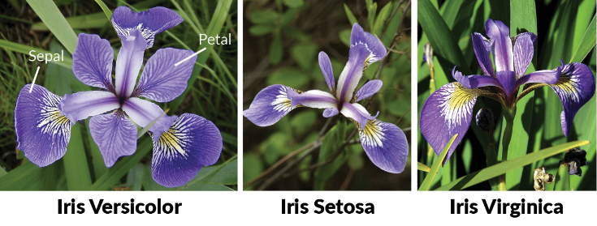

The Iris data set is a popular data set for demonstrating the concepts of machine learning and is often used as a benchmark for comparing the performance of different algorithms. It is a small and simple data set that is easy to understand and is well-suited for demonstrating the basic principles of machine learning.

6. **DataFrame** is a class in the pandas library that is used to create a two-dimensional data structure with rows and columns. It is similar to a spreadsheet or a SQL table, and it is often used to store and manipulate data in Python.

To create a pandas DataFrame, you can call the DataFrame() function and pass it a NumPy array or a list of lists as an argument. You can also specify the column names and index names as additional arguments.

In the expression DataFrame(dataset.target), dataset.target is assumed to be a NumPy array or a list containing the values for the rows of the DataFrame. The DataFrame() function creates a new DataFrame with a single column, using the values in dataset.target as the rows of the DataFrame.

**7. figure(figsize=(8,5))**

figure() is a function in the Matplotlib library that is used to create a new figure. It is often used in combination with other Matplotlib functions to create plots and visualizations.

The figure() function takes several optional arguments, including figsize, which is used to specify the size of the figure in inches. In the expression figure(figsize=(8,5)), the figsize argument is set to a tuple of (8, 5), which specifies that the figure should be 8 inches wide and 5 inches tall.

**8. K-Means Clustering**

K-Means Clustering is an unsupervised learning algorithm that is used to group data points into clusters based on their similarity. It is a popular algorithm that is widely used in a variety of applications, including data mining, image recognition, and customer segmentation.

The K-Means Clustering algorithm works by randomly selecting K initial centroids, where K is the number of clusters. It then assigns each data point to the nearest centroid, based on the Euclidean distance. The algorithm then recalculates the centroids as the mean of the data points in each cluster and reassigns the data points to the nearest centroid. This process is repeated until the centroids converge, which is typically achieved when the assignments of the data points to the clusters do not change.

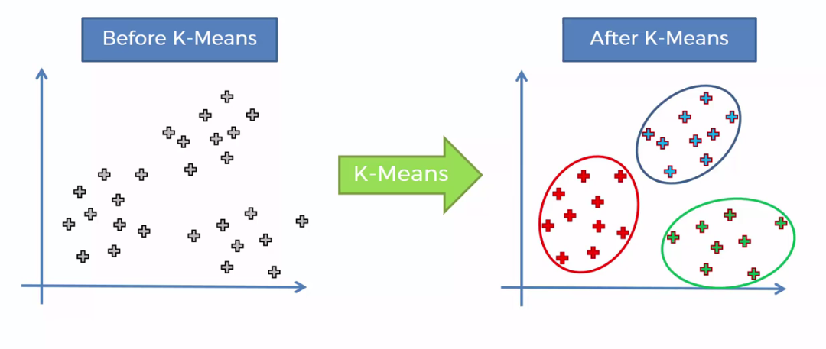

One of the main advantages of K-Means Clustering is its simplicity and efficiency. It is fast and easy to implement, and it can scale to large datasets. However, it can be sensitive to the initial centroids and may not always find the optimal solution.

K-Means Clustering is an important algorithm in the field of machine learning, and it is widely used for grouping data points into clusters based on their similarity. It is a powerful tool for unsupervised learning and is commonly used in a variety of applications.

**9. preprocessing.StandardScaler()**

StandardScaler is a class in the scikit-learn library that is used to standardize the features of a dataset. Standardization is a common preprocessing step in machine learning that involves scaling the features of a dataset to have zero mean and unit variance. This can be useful for many algorithms, as it can help to improve the model's performance and reduce the sensitivity to the scale of the features.

To use StandardScaler, you will need to import it from the sklearn.preprocessing module and create an instance of the StandardScaler class. Then, you can call the fit() method on the instance to fit the scaler to the data, and the transform() method to standardize the data.

**8. scatter(X.Petal_Length, X.Petal_Width, c=colormap[y_cluster_gmm], s=40)**

The expression scatter(X.Petal_Length, X.Petal_Width, c=colormap[y_cluster_gmm], s=40) calling the scatter() function from the Matplotlib library to create a scatter plot.

The scatter() function takes several arguments, including X.Petal_Length and X.Petal_Width, which are columns in a pandas DataFrame or a NumPy array containing the values for the x-axis and y-axis of the scatter plot, respectively. The c argument is assumed to be an array of values used to specify the colors of the points in the scatter plot, and the s argument is a scalar value used to specify the size of the points in the scatter plot.

colormap is a list or array of colors, and y_cluster_gmm is an array of class labels or cluster assignments for the points in the scatter plot. The expression colormap[y_cluster_gmm] is using the values in y_cluster_gmm as indices to select the corresponding colors from the colormap list.

This expression part of a script that is using the scatter() function to create a scatter plot of the Petal_Length and Petal_Width features, and it is using the values in y_cluster_gmm to color the points in the scatter plot according to their class or cluster membership.

**9. plt.title('GMM Classification')**

The expression plt.title('GMM Classification') is calling the title() function from the Matplotlib library to add a title to a plot.

The title() function takes a string as an argument, which specifies the text for the title. In this case, the title is set to 'GMM Classification'.

**10. plt.subplot(1,3,2)**

The expression plt.subplot(1, 3, 2) is calling the subplot() function from the Matplotlib library to create a subplot within a larger figure.

The subplot() function takes three integers as arguments: nrows, ncols, and index, which specify the number of rows and columns in the grid of subplots, and the index of the subplot. In this case, the subplot() function is called with nrows=1, ncols=3, and index=2, which means that the subplot will be part of a grid with 1 row and 3 columns, and it will be the second subplot in the grid.

**11. from sklearn.datasets import load_iris**

The expression from sklearn.datasets import load_iris is a Python import statement that is used to import the load_iris function from the sklearn.datasets module.

The load_iris function is a function from the scikit-learn library that is used to load the Iris data set, which is a well-known and widely used data set in the field of machine learning. The Iris data set consists of 150 records, each representing the measurements of the sepal length and width, and petal length and width of one of three species of Iris flowers: Iris setosa, Iris virginica, and Iris versicolor.

To use the load_iris function, you will need to import it from the sklearn.datasets module, as shown in the expression above. Once the function has been imported, you can call it to load the Iris data set and access the data and labels through the data and target attributes of the returned object.

**12. predY=np.choose(model.labels_,[0,1,2]).astype(np.int64)**

The expression predY = np.choose(model.labels_, [0, 1, 2]).astype(np.int64)using NumPy's choose() and astype() functions to perform operations on an array of values.

The choose() function is a NumPy function that takes two arguments: an array of indices and an array of choices. It returns an array of the same shape as the indices array, with each element containing the corresponding element from the choices array. In this case, the choose() function is being called with model.labels_ as the indices array and [0, 1, 2] as the choices array. This means that the resulting array will have the same shape as model.labels_, and each element will be chosen from the choices array based on its index in model.labels_.

The astype() function is a NumPy function that takes a data type as an argument and returns an array with the same shape and values as the original array, but with the specified data type. In this case, the astype() function is being called with np.int64 as the data type, which means that the resulting array will be of type int64.

The predY variable is being assigned the result of the choose() and astype() functions, which means that it is an array of values that has been chosen from the [0, 1, 2] array based on the indices in model.labels_ and has been cast to the int64 data type.

**13. colormap=np.array(['red','lime','blue'])**

The expression colormap = np.array(['red', 'lime', 'blue']) is creating a NumPy array called colormap that contains the values 'red', 'lime', and 'blue'.

**14. xsa=scaler.transform(X)**

The expression xsa = scaler.transform(X) appears to be calling the transform() method of a scaler object to transform the data in an array or DataFrame X.

The transform() method is a common method in machine learning libraries that is used to apply a transformation to a dataset. In this case, the scaler object is assumed to be an instance of a class that implements a data transformation, such as a scaler or normalizer. The transform() method is being called with X as an argument, which applies the transformation to the data in X and returns the transformed data.

The xsa variable is being assigned the result of the transform() method, which means that it is an array or DataFrame containing the transformed data.

**15. Summary of the Code**

This program is doing a comparison of two clustering techniques, K-Means and Gaussian Mixture Model (GMM), on the Iris dataset, which is a well-known dataset in the machine learning community.

The Iris dataset consists of 150 samples of iris flowers, with four features (sepal length, sepal width, petal length, petal width) and three classes (Iris Setosa, Iris Versicolour, and Iris Virginica). The script first loads the Iris dataset using the load_iris function from scikit-learn (sklearn). It then prints some information about the dataset, such as the data and the names of the features and classes.

Next, the program creates a Pandas DataFrame X from the feature values in the dataset, and adds column names. It also creates a DataFrame y from the class labels in the dataset, and adds a column name.

The program then creates a matplotlib figure with 3 subplots and plots the relationship between petal length and petal width for each subplot. The first subplot shows the relationship without any clustering, with each sample colored according to its class. The second and third subplots show the relationship after applying K-Means and GMM, respectively, with each sample colored according to the cluster it belongs to.

To apply K-Means, the script creates a KMeans object with n_clusters set to 3 (since there are 3 classes in the Iris dataset), and fits it to the data using the fit method. It then uses the labels_ attribute of the KMeans object to get the cluster labels for each sample, and uses these labels to color the samples in the second subplot.

To apply GMM, the program first standardizes the feature values using preprocessing.StandardScaler, which helps GMM perform better. It then creates a GaussianMixture object with n_components set to 3 (since there are 3 classes in the Iris dataset), and fits it to the standardized data using the fit method. It then uses the predict method of the GaussianMixture object to get the cluster labels for each sample, and uses these labels to color the samples in the third subplot.